
Year 8 Mathematics
Mini Test
Circles

Resources: one A4 page of notes and a calculator

Name: _______________________________ / 23 marks Time: 25 mins

Full working out must be shown to get full marks. Attempt all the questions.
Round answers to one decimal place.

Question 1 (3 marks)
Name the dotted line on each circle
Diagram | Name
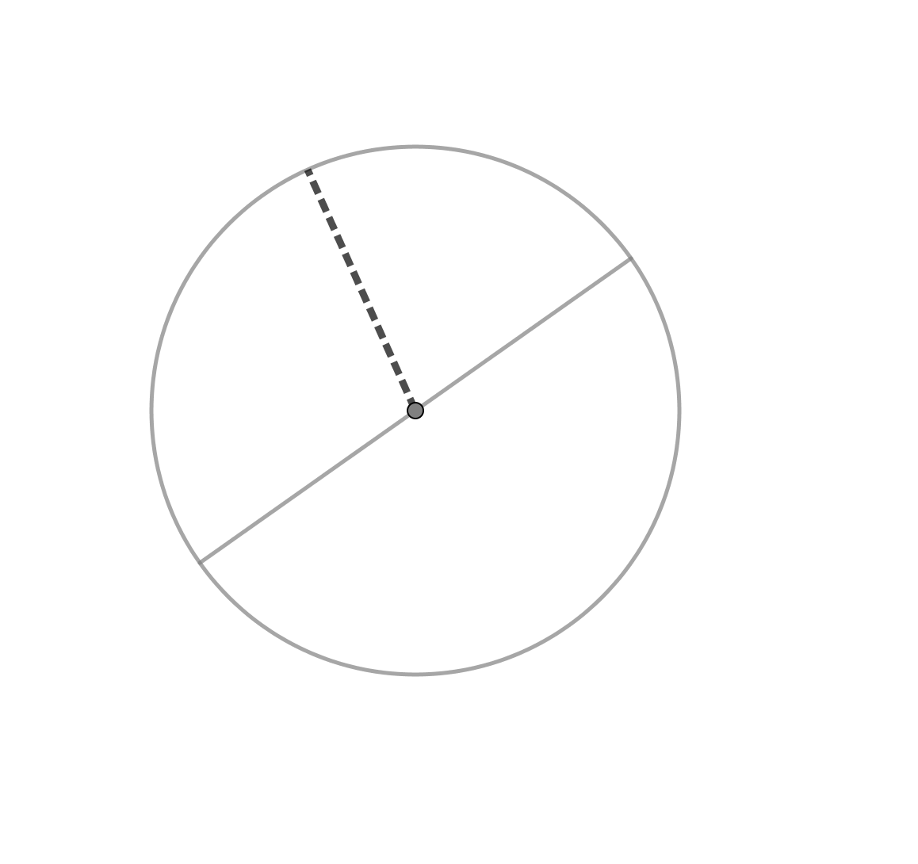
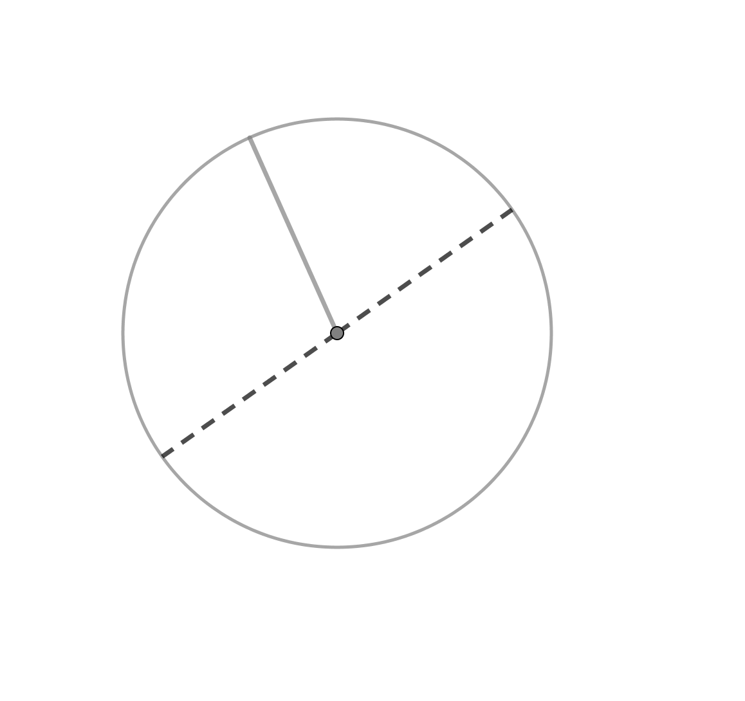
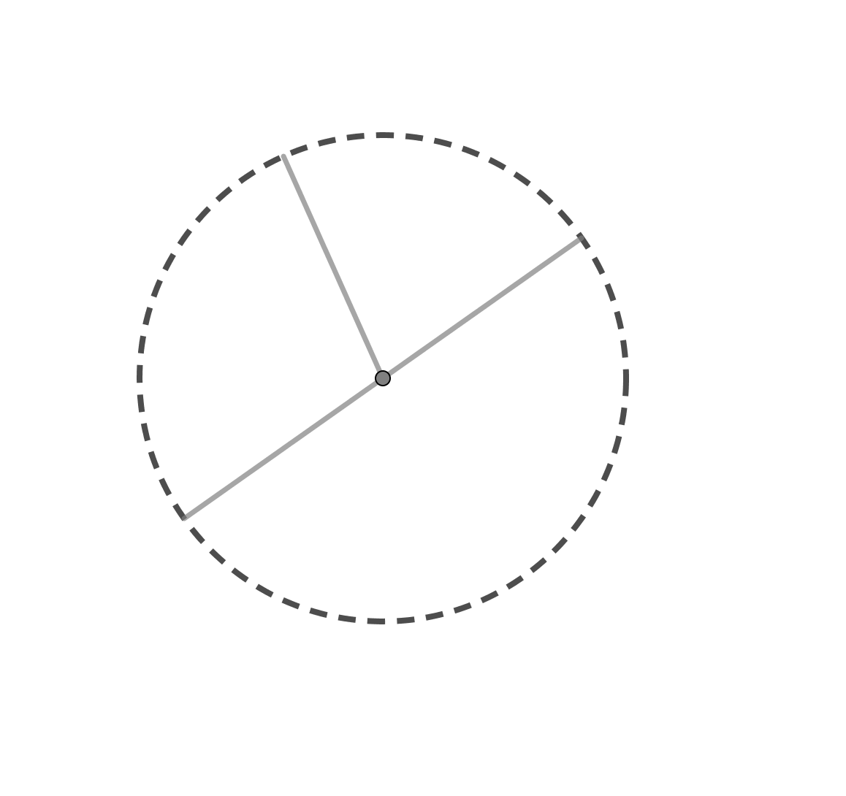

Question 2 (8 marks)
Find the circumference and the area of the following circles
Circle | Circumference | Area
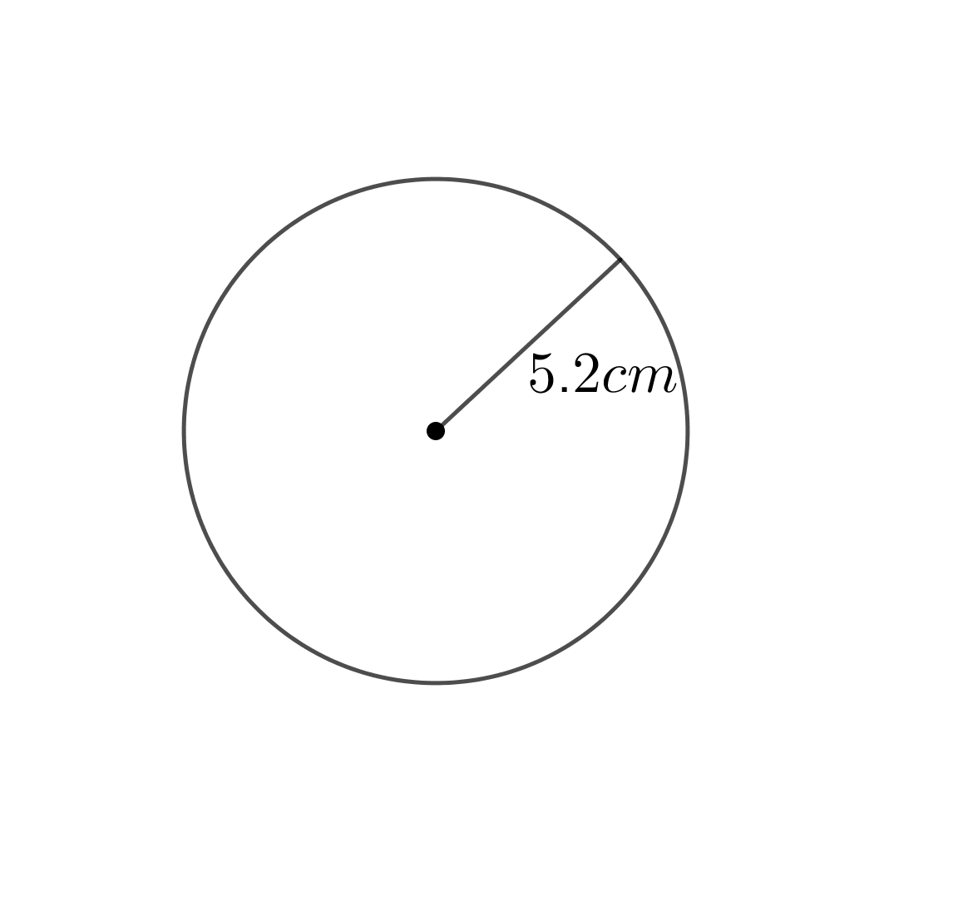
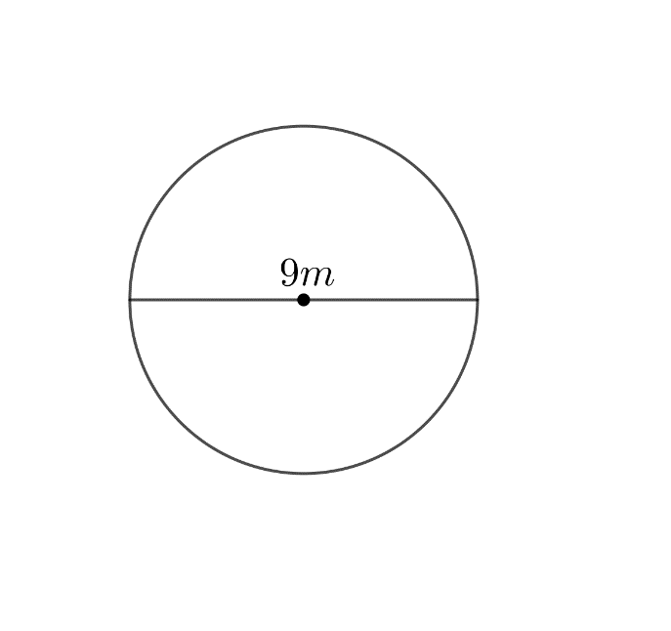

Question 3 (3 marks)
Find the area of the semi-circle
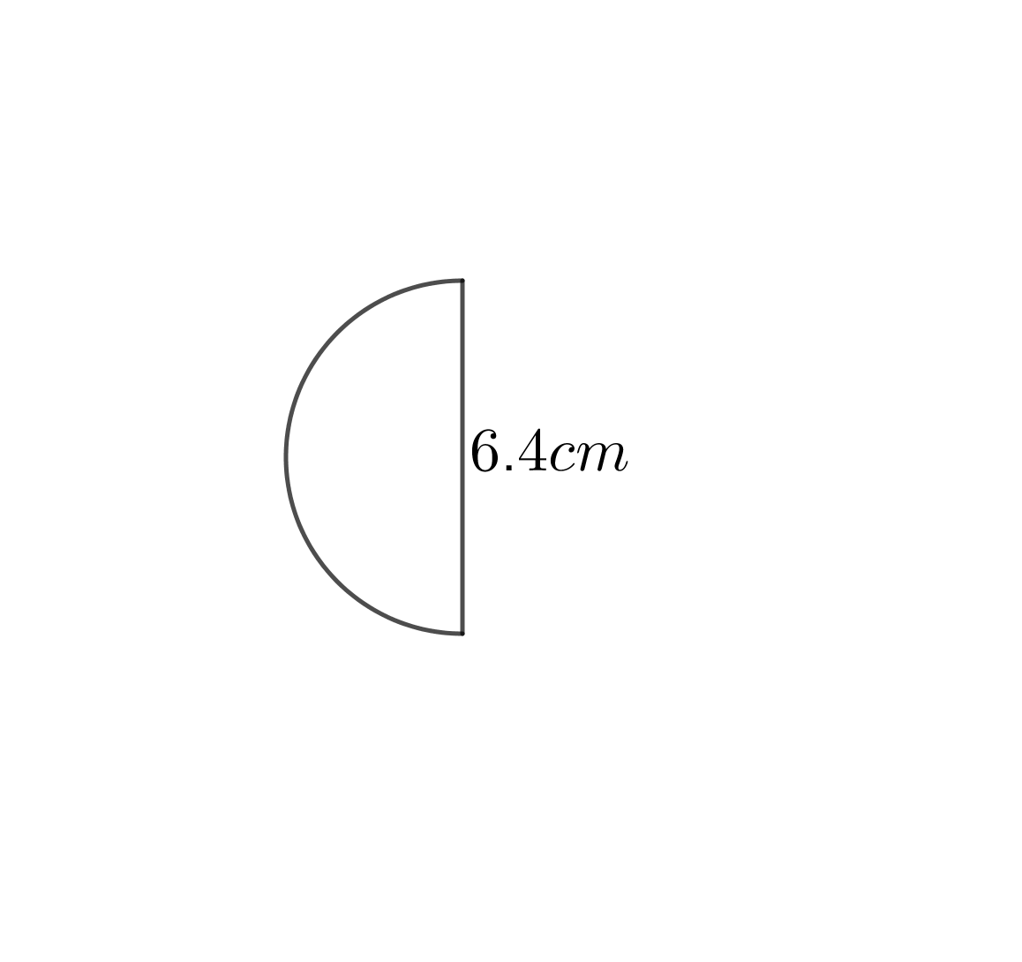
Question 4 (3 marks)
A yoyo at the end of a string moves through a quarter circle, as shown below. Find the curved distance travelled by the yoyo.

Question 5 (6 marks)
- A child’s bike tyre has a circumference of 90cm. What is the radius of the circle?

- An adult bike tyre has a diameter of 70cm. How many full turns will the tyre make if the bike travels 500m?

End of Test

